Introducing eLearning opportunities to School Teachers (k-12)
“Getting Your Class Online”

case study

Chris Smith B.Sc., P.G.C.E.
csmith@csmith.info
http://www.shambles.net/elearning

The Education Project Asia

Abstract

This case study shares some of the experiences gained when introducing some k-12 teachers in International Schools to the opportunities available on the internet to “get their class online” and support learning and teaching.

The examples given and materials shown are practical applications and would be of particular interest to teachers, school managers and to those involved in teacher education and training.

It is possible to successfully introduce teachers, with minimal internet experience, to applications that can be set up at little or no expense (providing the school has an internet connection) using application service providers (ASPs).

As an example, this paper illustrates how, when working with a group of teachers, a BLOG, Website and listserv can all be set up in ninety minutes therefore empowering the teachers to specifically encourage online co-operative group work with their students.

This paper does not aim to describe the detailed specifics of the event but the presentation of the paper will model the process used for delivery.

1 Introduction

  - Chris Smith biography
Chris Smith has been working with International School teachers in S.E.Asia for 26 years, the first 24 with the English Schools Foundation (ESF) in Hong Kong, a group of 16 schools, 12,000 students and 800 teachers.

During his last three years with the ESF, as the ICT Advisor, he set up and monitored an in-service ICT programme for all teaching and library staff.

In 2002 he moved to Thailand and established a consultancy “The Education Project Asia” to extend these support opportunities to other International Schools across 17 countries in S.E.Asia focused on the “Integration of ICT in Teaching and Learning”.

  - Background
The acceptance of the importance of ICT in International Schools in the region by both educators and managers in these schools is now a reality.

Despite this acceptance not all schools are able to integrating the technology into teaching and learning as fast as they would like to.
A number of reasons are suggested for this:
- budgetary limitations
- lack of polices
- physical limitations (just no space)
- lack of in-house expertise
- country infrastructure (e.g. broadband)
- students not having machines at home
- students not being connected to the internet at home

During the transition that is happening many schools now have excellent whole-school networks (LAN) with broadband connectivity to the Internet.

Some of these schools have yet to decide on which content management systems (CMS) and learning management systems (LMS) to use and have yet to establish relevant policies.

This has resulted in some teaching staff asking for advice on how they may use the internet now to support their class immediately without waiting for the implementation of a whole-school CMS/LMS.

In response to this request a staff in-service session has been designed and delivered (by Chris Smith) entitled “Getting Your Class Online”

  - “Getting Your Class Online”
For this in-service event to be appropriate it is expected that:
- the school has a LAN with a broadband connection
- staff are familiar with using Internet Explorer and with disk/file management
- students have internet connectivity at home

  - “Getting Your Class Online” Website
www.shambles.net/elearning
A webpage was modified to include support materials for this event … see live online or look at fig 1

  - Application Service Providers (ASP)
The approach makes use of ASPs many of which are free … specifically:
- BLOG: Blogger
- Website: eBoard
- Listserv: smartgroups

  - Getting Your Class Online” The EVENT
This paper does not aim to describe the detailed specifics of the event but the presentation of the paper will model the process used for delivery.

Summary
This strategy has proven to be extremely successful in motivating teachers who have minimal ICT skills or who are apprehensive about using ICT and the internet with their class.

The use of an ASP is an excellent solution to first introduce teachers and students to online elearning tools. They are low cost, low risk and require low learning curves.

Experience indicates that a blended approach where staff makes use of a whole-school LMS while still taking advantage of individual ASPs is feasible. In fact some schools are now taking the ASPs model to supply their school-wide CMS/LMS.

As a final word of caution: school managers need to be aware of the ramifications of empowering teachers in this way, especially when considering ‘quality assurance’ and ‘copyright’.

Fig 1 Shambles website
www.shambles.net/elearning
elearning page

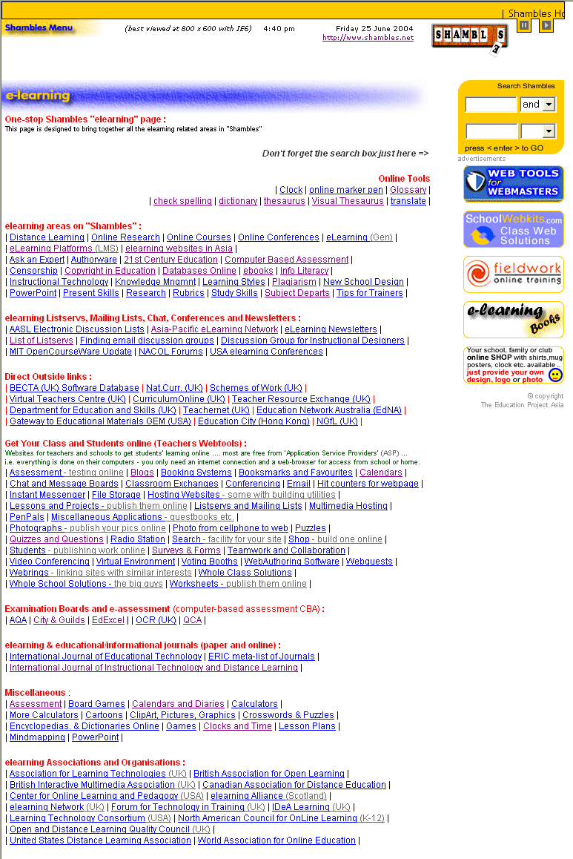

Fig 2 BLOG
www.google.com




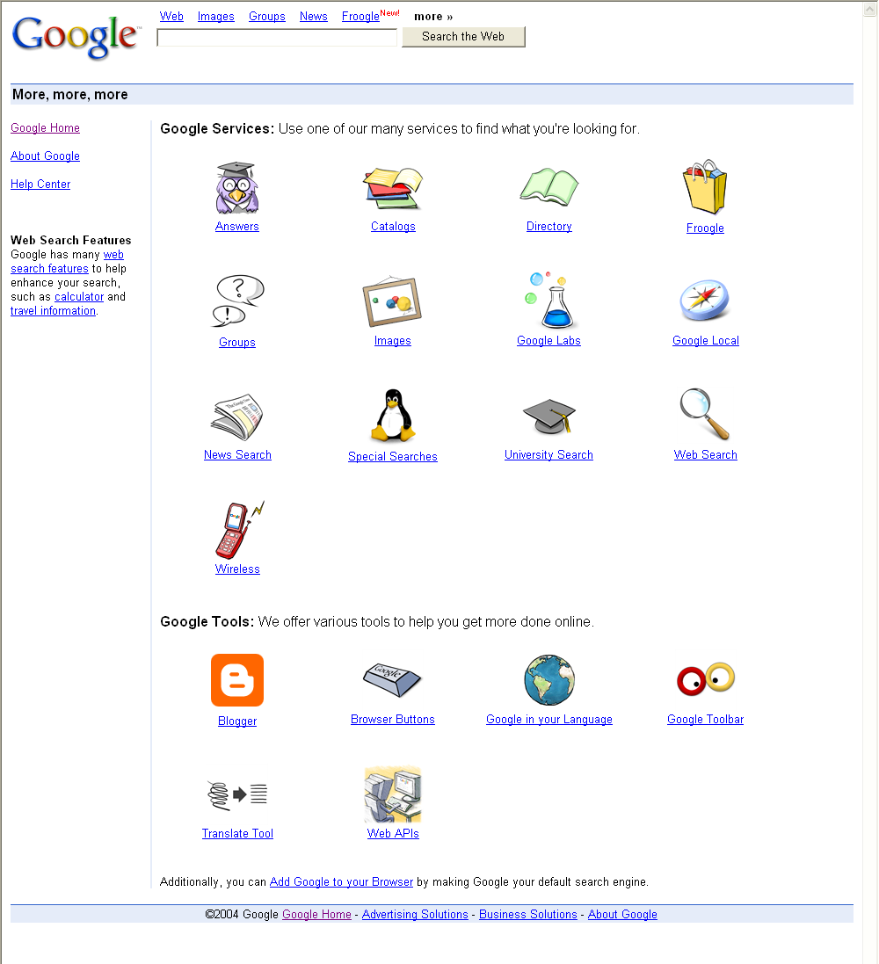

Fig 3 listserv
www.smartgroups.com

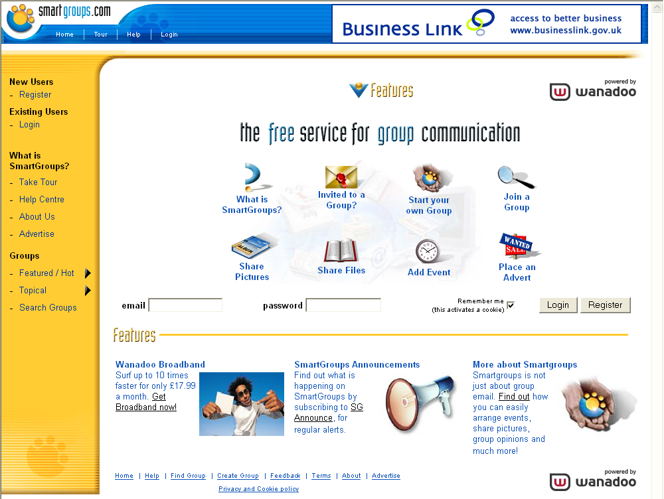

Fig 4 website
www.eboard.com
http://shambles.eboard.com

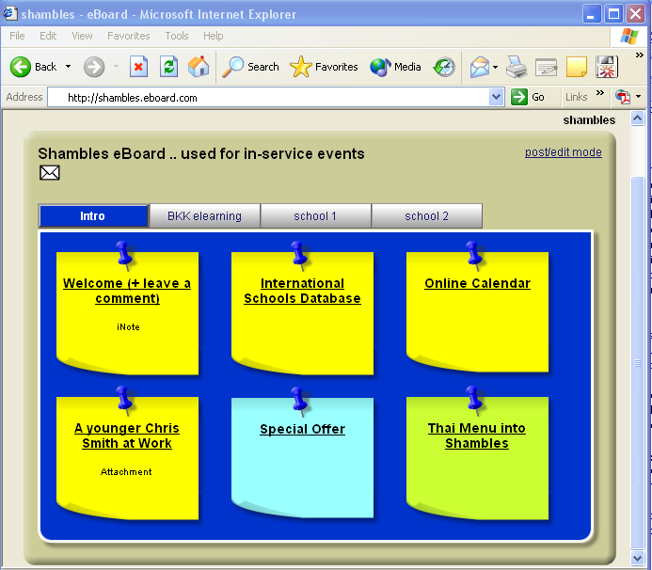

For other examples of how eboard can be configured go to:
http://www1.eboard.com/eboard/Site/samples.jsp

END

